

Asset detection, reconnaissance, and monitoring

Tony (YIT19488399)

**Roehampton university**| CMP020X305S **Monday, 27 February 2023**

**PORTFOLIO 2, Cyber-Security**

**INTRODUCTION:**

Screenshots will be commented and sketching for better and faster understanding. Friday, 03 of March 2023, in laboratory area and laboratory time is possible to deliver clarifications about this document in person.

I will start from point 2 in requirements A to set out that if gateway in turned off, there are no communication nor networking between hosts on the sandboxed network. And I will demonstrate that host name can be different from association of IPs to names that should be the host names. This is the case for *gateway* and *bitnami* VMs.

Afterwards, I will ping to host names as instructions, and host numbers (only with Zabbix VM), and the outcome should be the same. For requirements B, screenshots have extra *nmap* commands found online. Finally, *nmap* has built in scripts to find vulnerabilities, exploit them, authentication, brute, and more. Many screenshots cover few points from requirements B and original and this paper were produced, being this one (my own) more precise guided.

As “Wow Factor, I participated in few discussions on Moodle. Requirements A and B have some extra content included that is visible on screenshots. Plus I installed Python in Kali and I executed a simple command from file using CLI.

**Requirement A: Demonstration Tasks**

1. From the **gateway**, demonstrate that you can successfully ping the kali, wordpress, analytics and zabbix host names.
2. From the **kali**, demonstrate that you can successfully ping the gateway, wordpress, analytics and zabbix host names.
3. From the **wordpress**, demonstrate that you can successfully ping the gateway, kali, analytics and zabbix host names.
4. From the **analytics**, demonstrate that you can successfully ping the gateway, kali, wordpress and zabbix host names.
5. From the **zabbix**, demonstrate that you can successfully ping the gateway, kali, wordpress and analytics host names.

2.



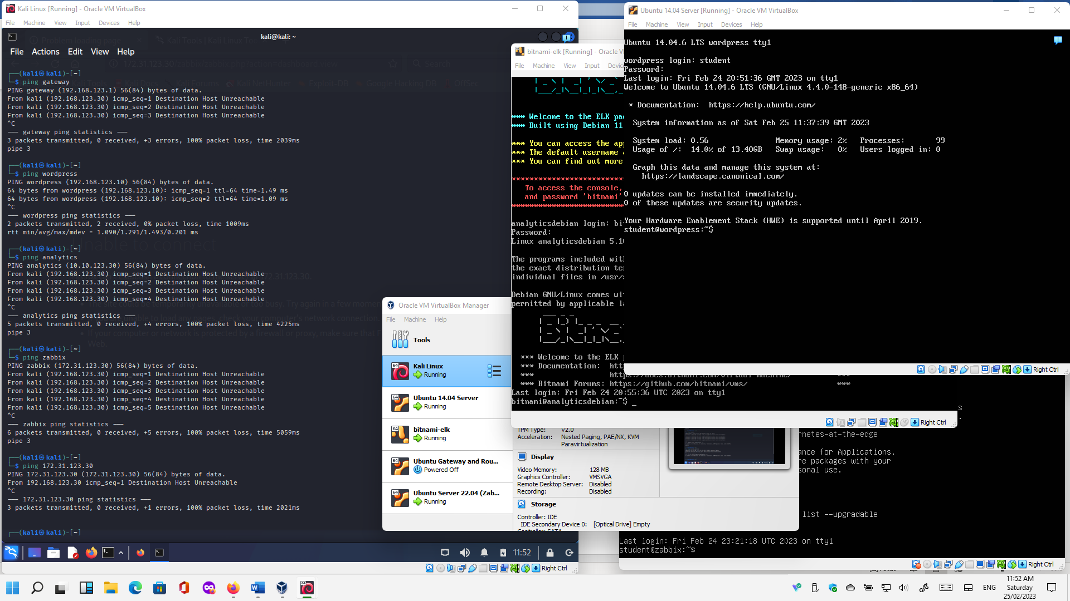



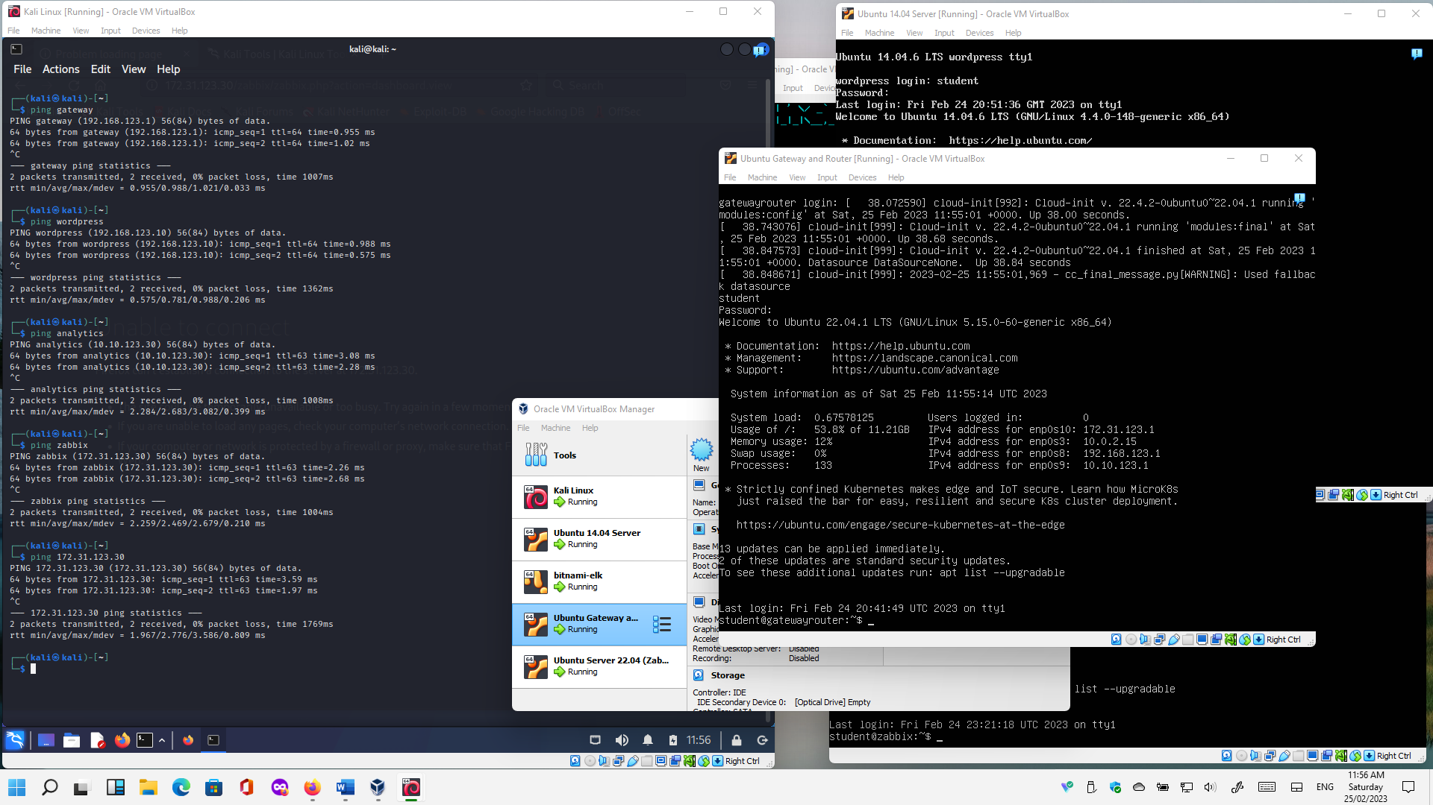



3.

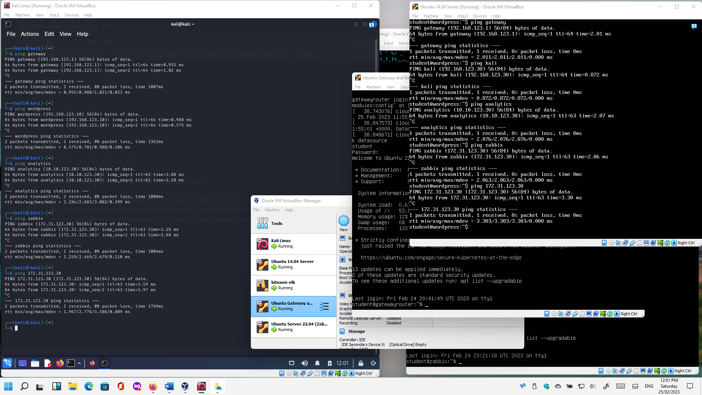



4.

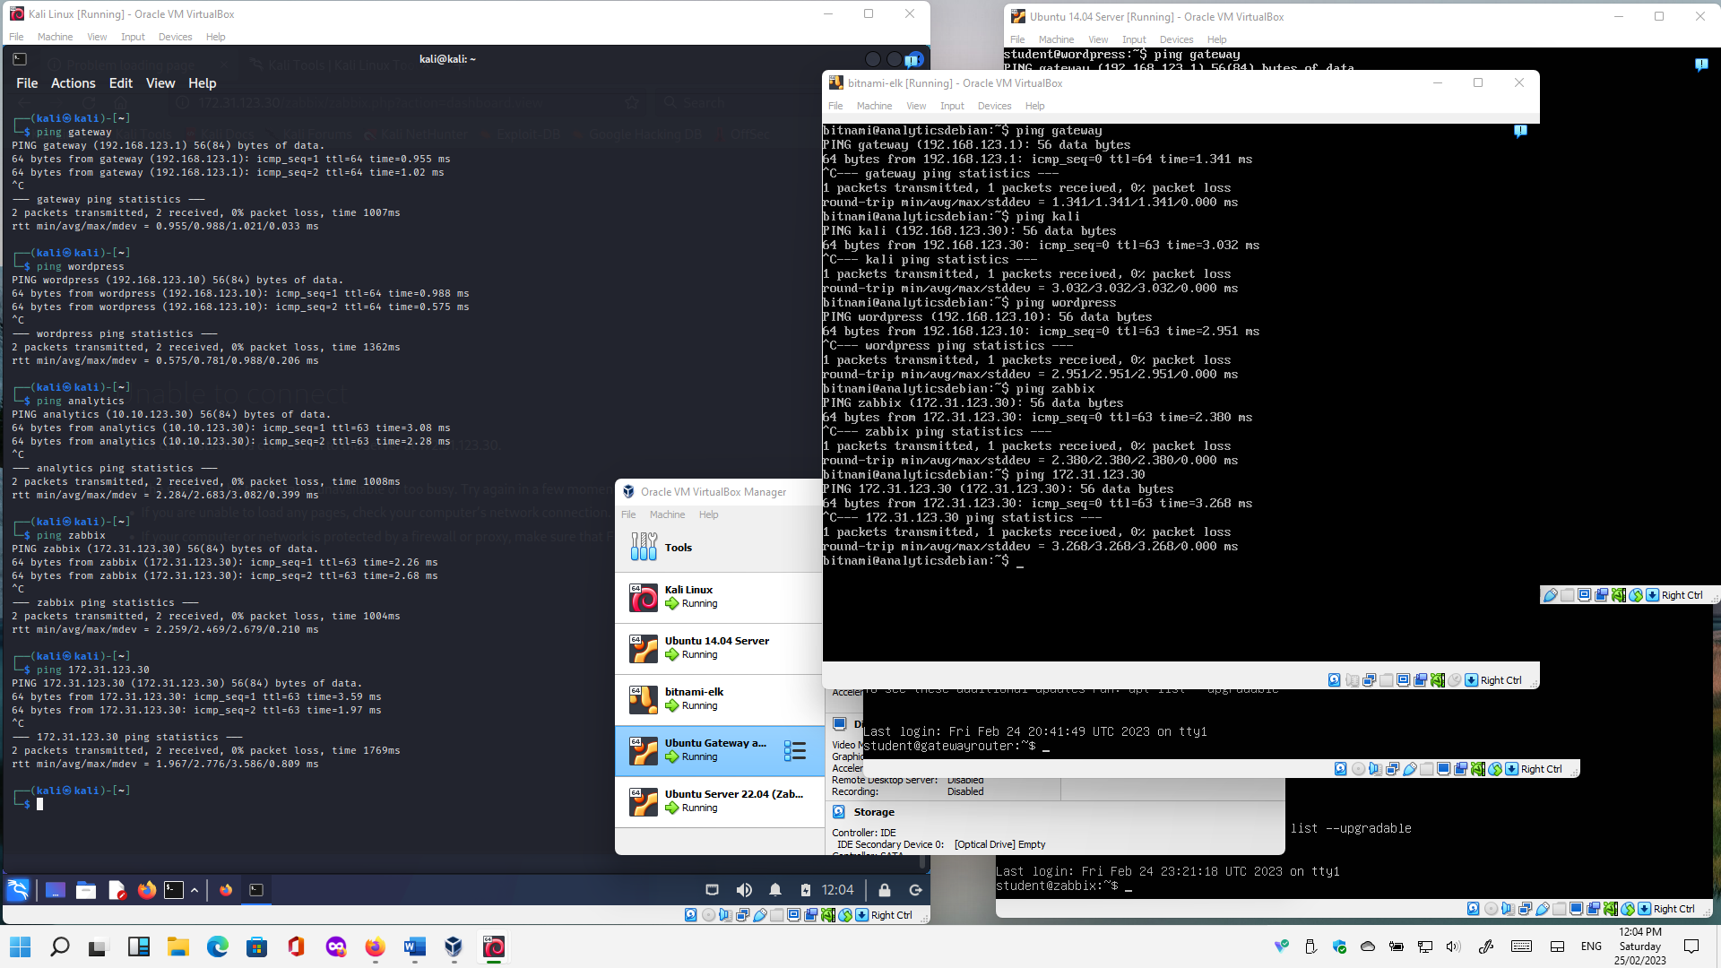



5.

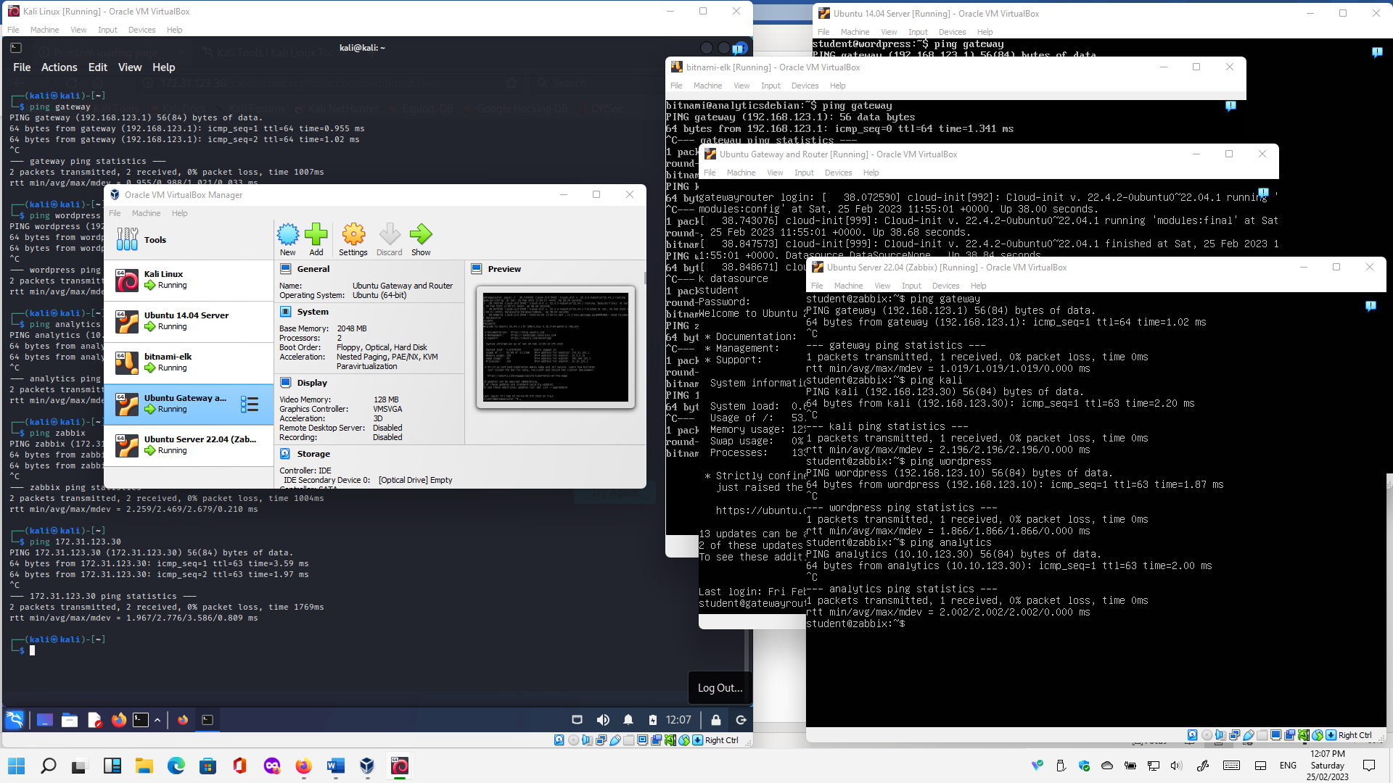



1.

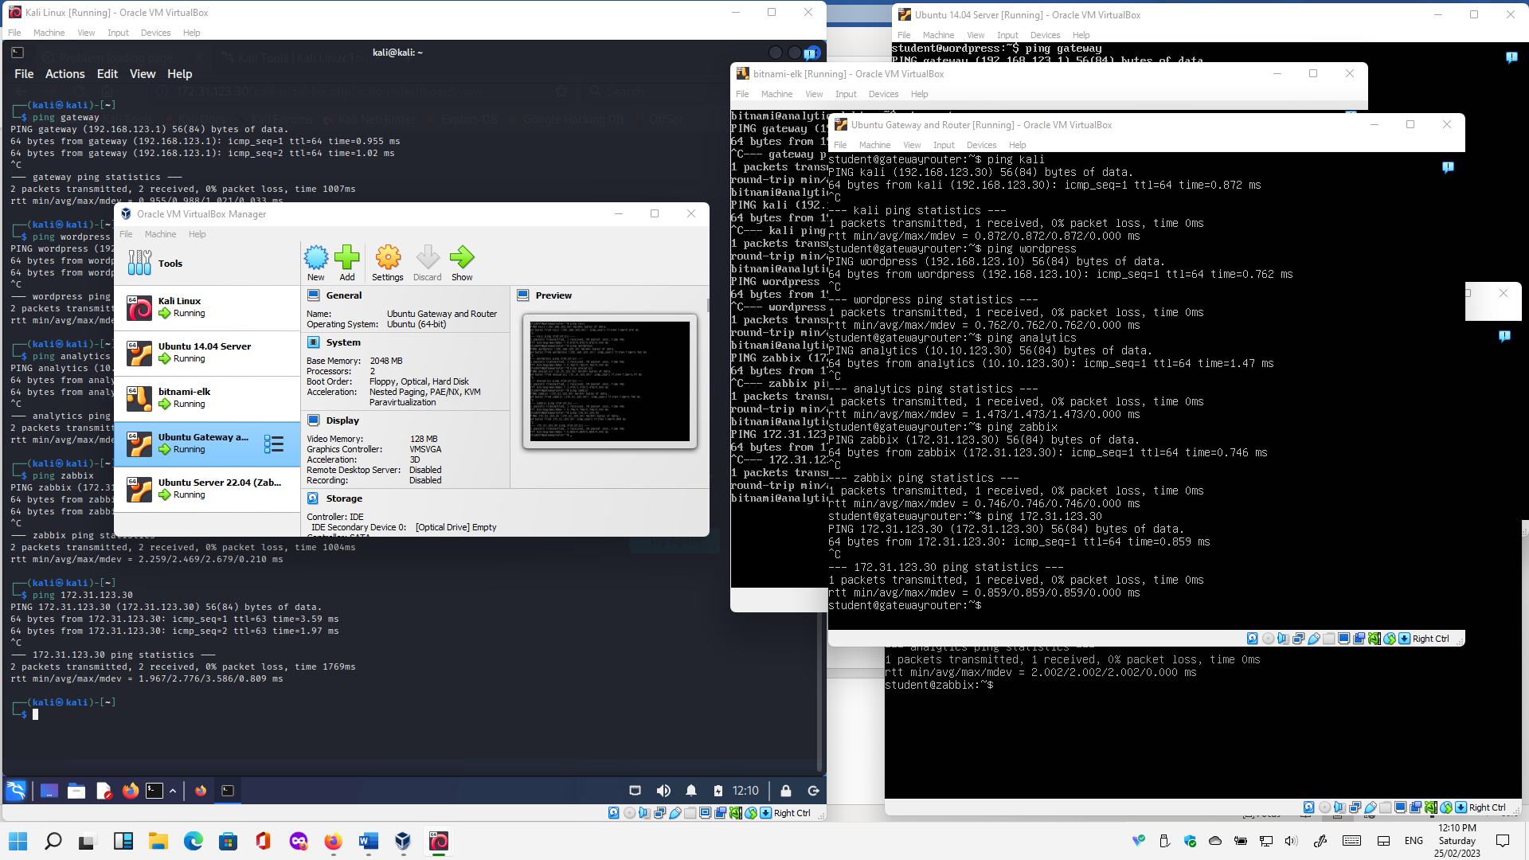



Wow factor demonstration A:

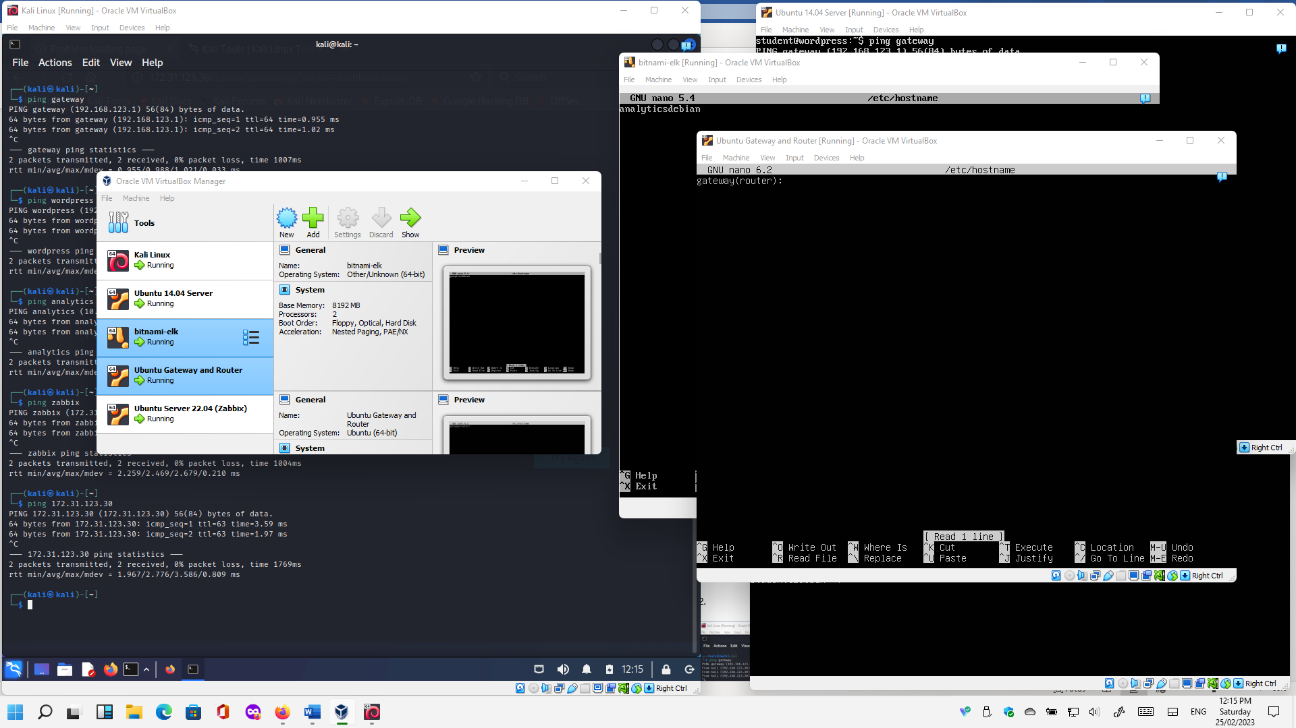



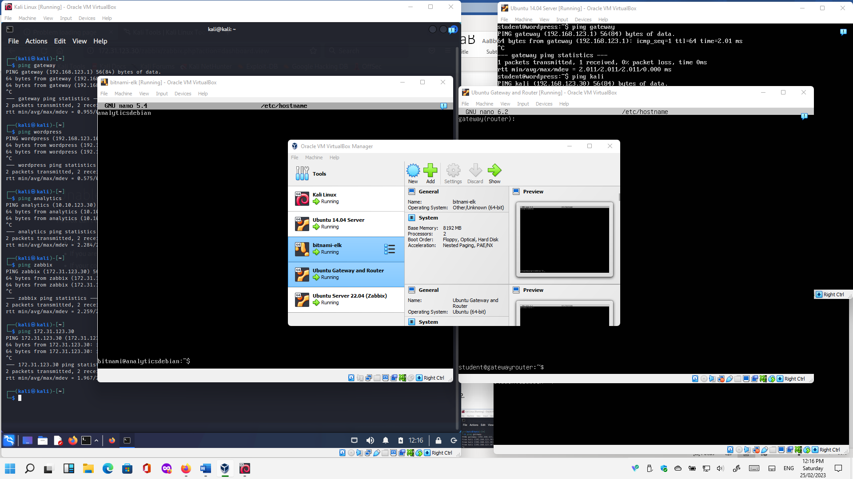



**Portfolio Requirement B: Exploring NMAP Commands**

From your Kali virtual machine, test the following **nmap** commands on your sandboxed network. 1 to 16 different commands.

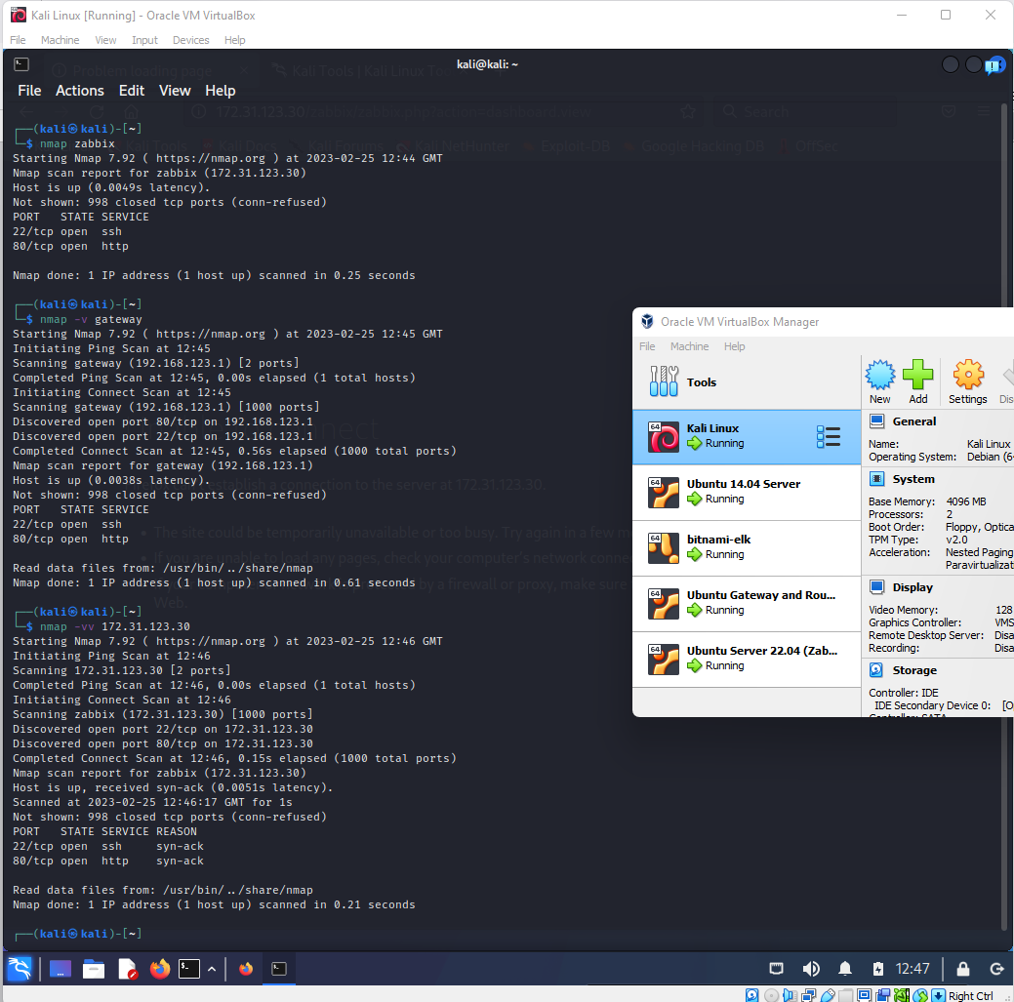

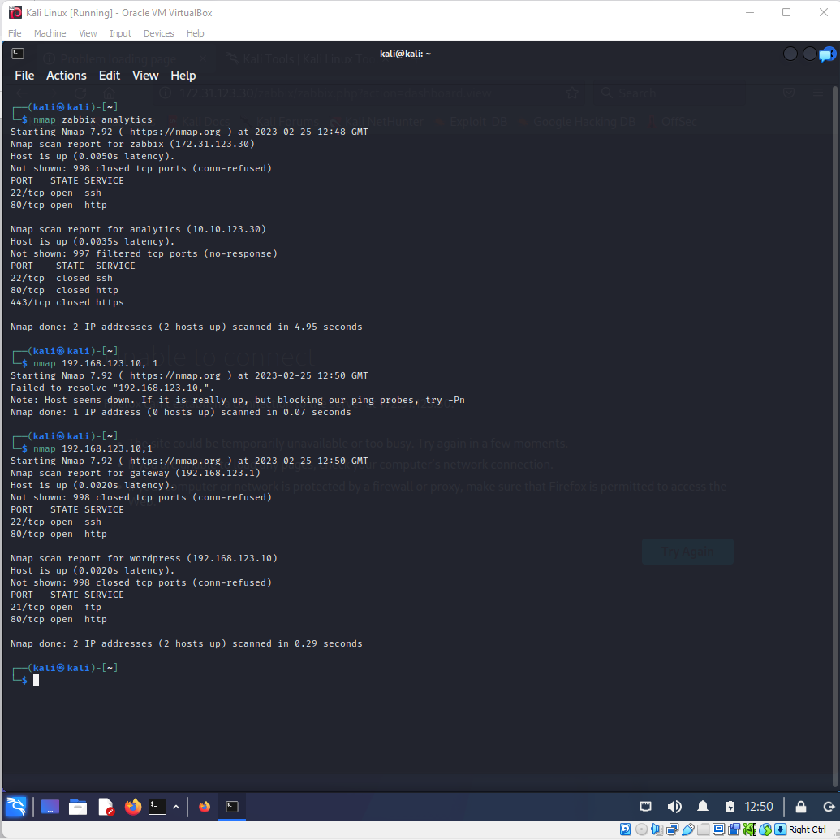

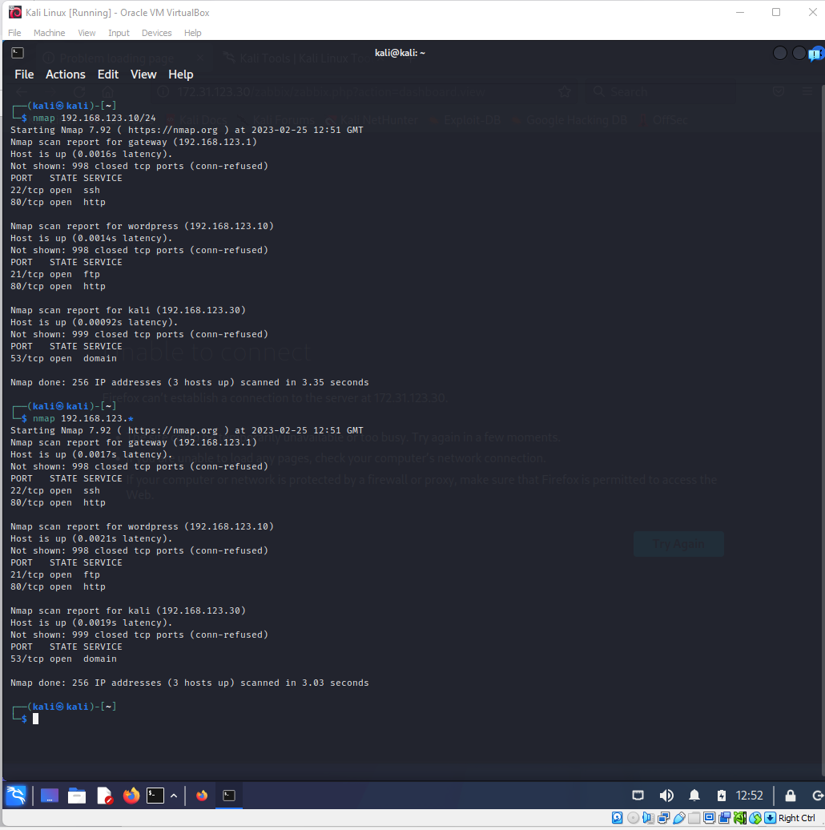

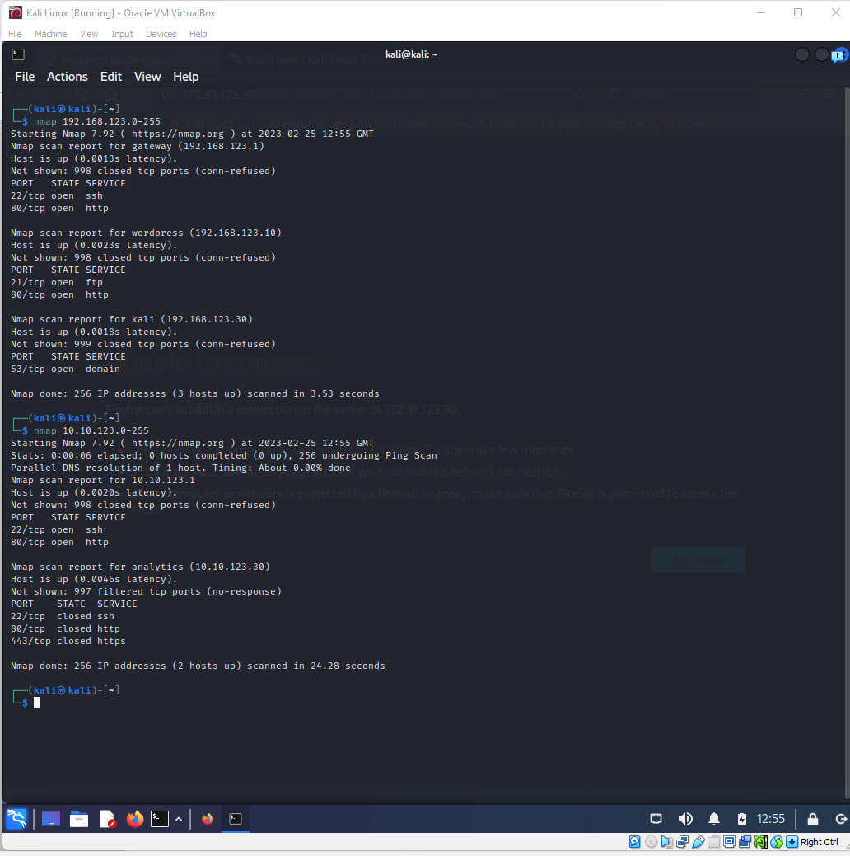

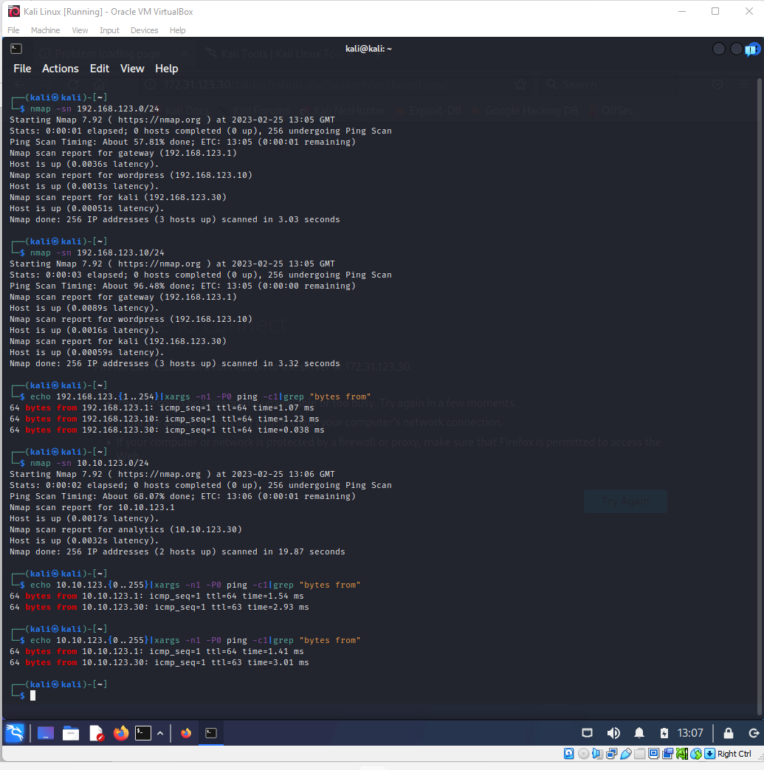

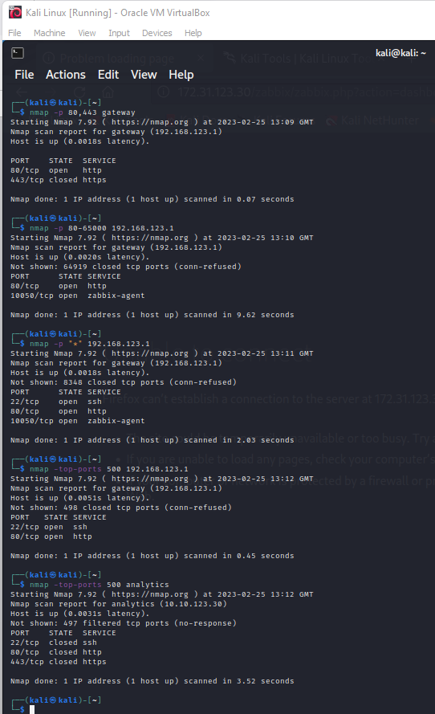

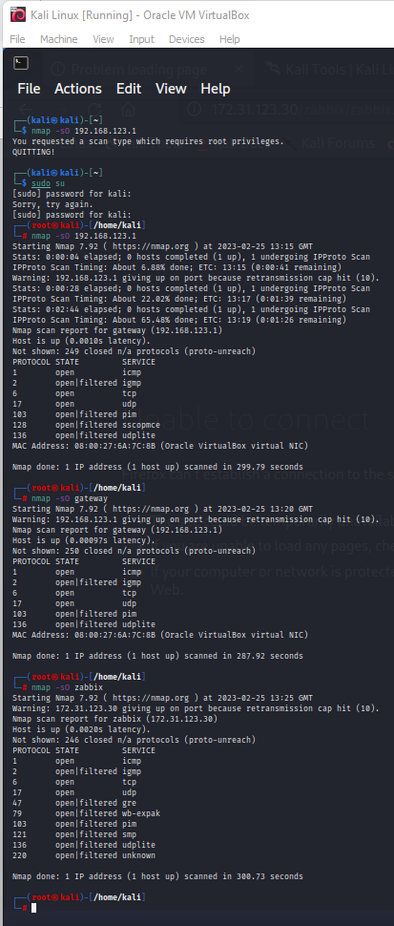

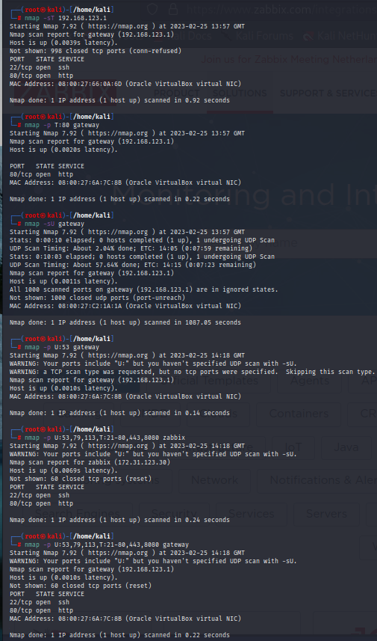

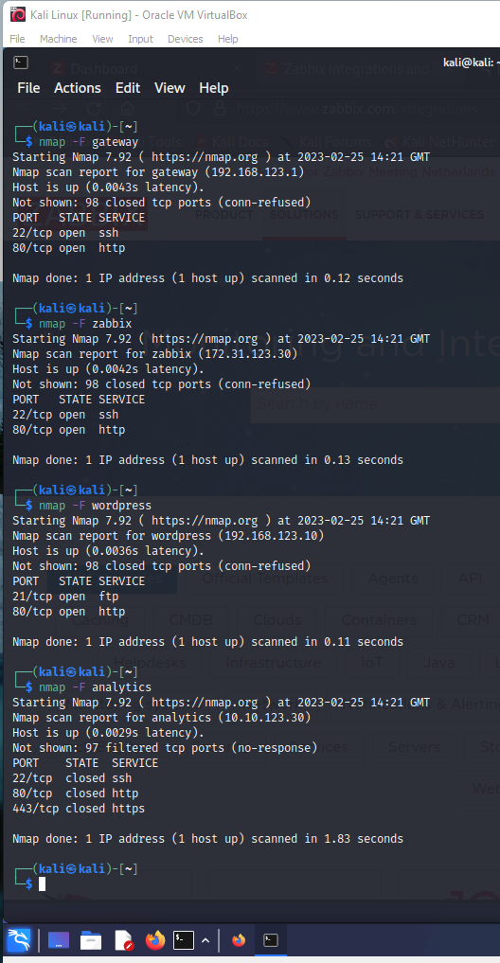

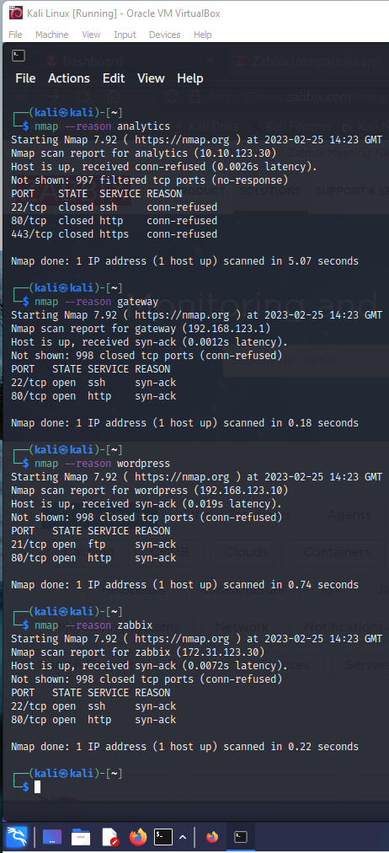

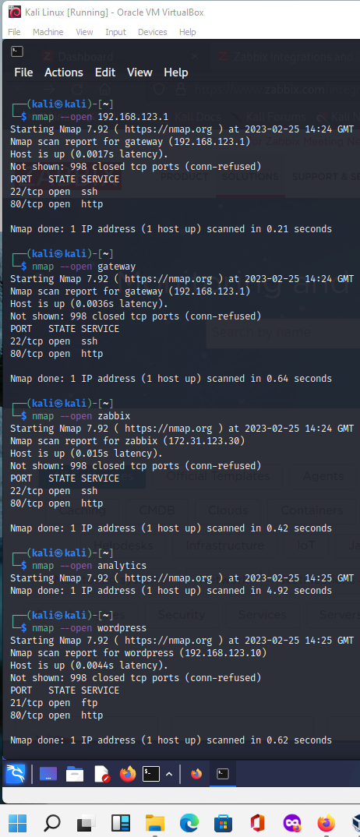

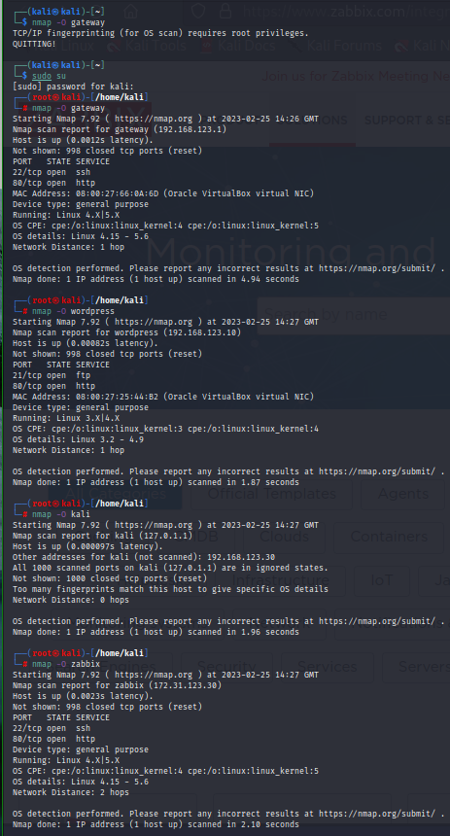

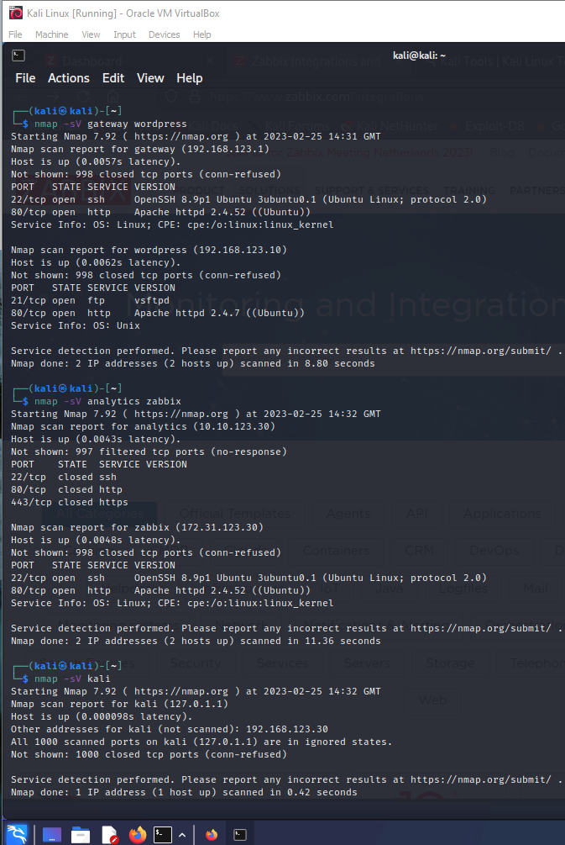

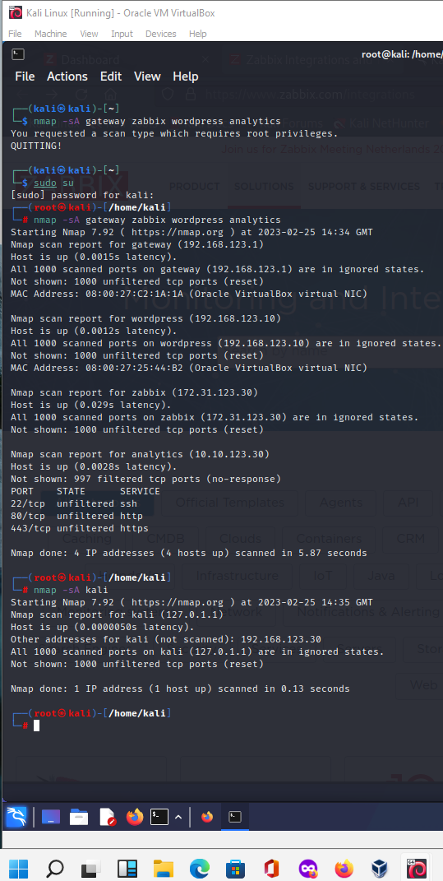

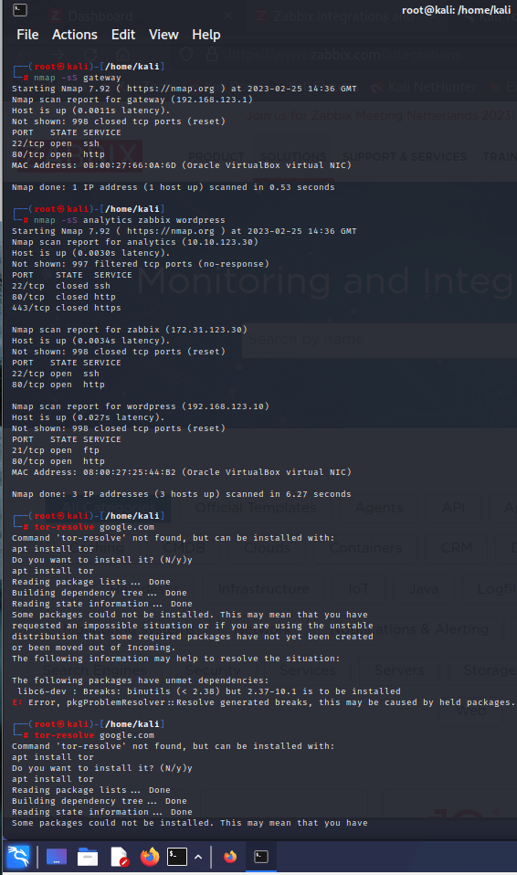

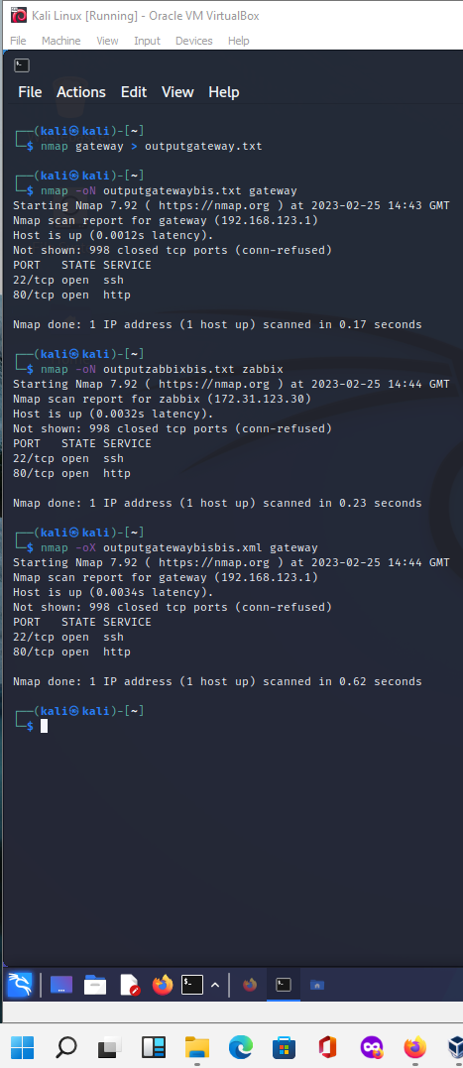

**Wow factor Req. B (build in scripts from *nmap*):**

[1] [2] [3] [4] [5]

# Bibliography

|  |  |
| --- | --- |
| [1] | [Online]. Available: https://www.tecmint.com/use-nmap-script-engine-nse-scripts-in-linux/ . |
| [2] | [Online]. Available: https://securitytrails.com/blog/nmap-scripts-nse . |
| [3] | [Online]. Available: https://www.cybervie.com/blog/nmap-and-useful-nse-scripts/ . |
| [4] | [Online]. Available: https://nmap.org/book/nse-usage.html . |
| [5] | [Online]. Available: https://www.shellhacks.com/find-active-computers-local-network-linux/. |
| [6] | [Online]. Available: https://www.shellhacks.com/find-active-computers-local-network-linux/. |

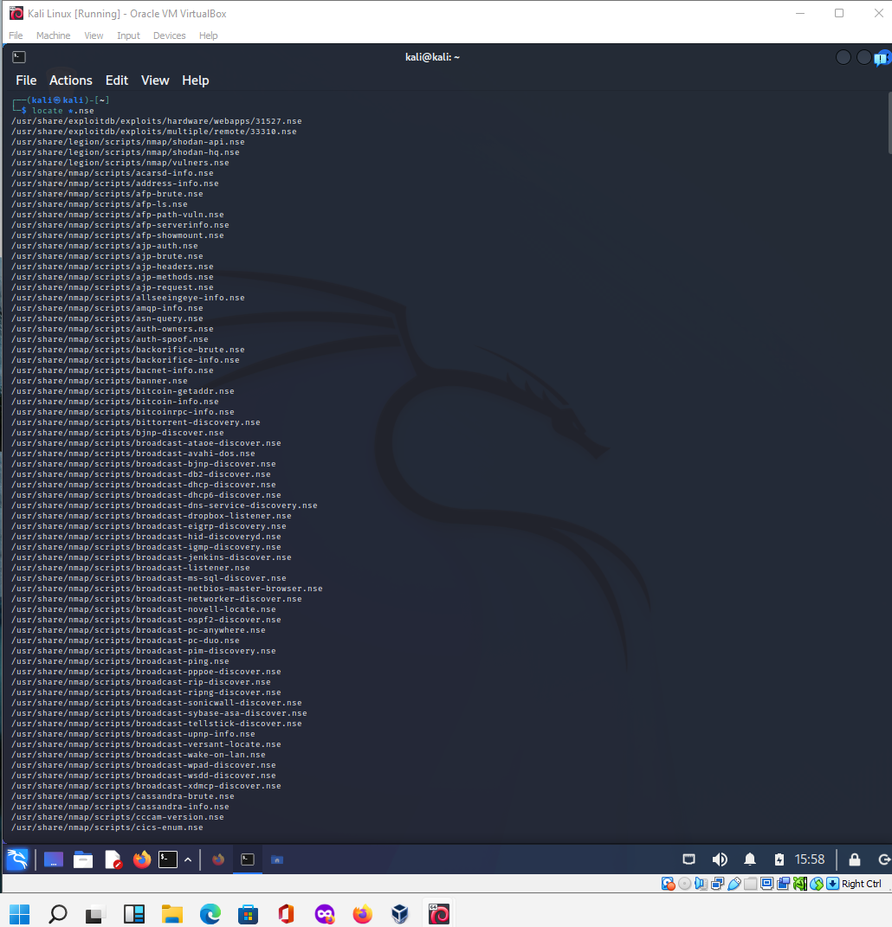

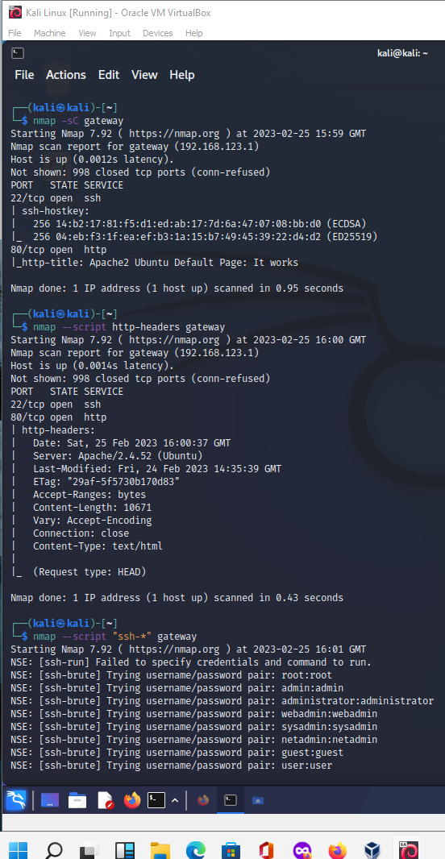

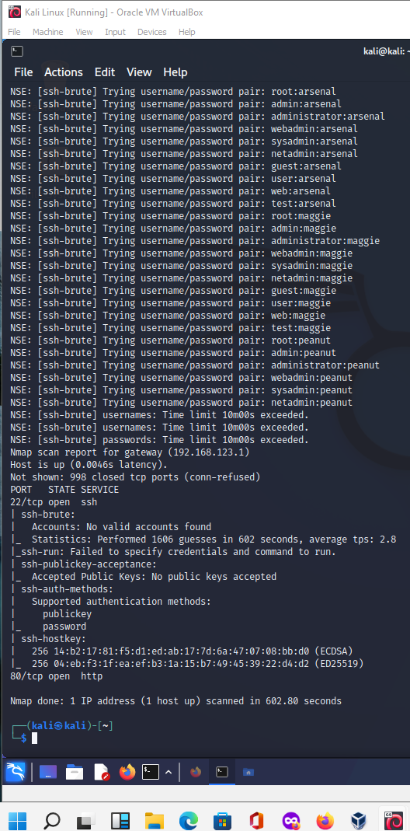

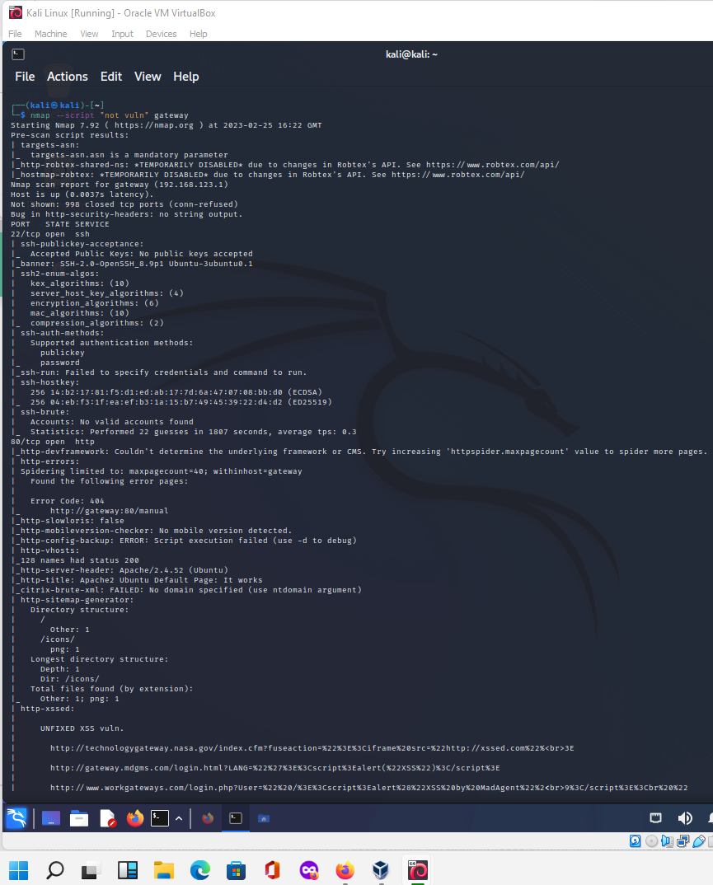

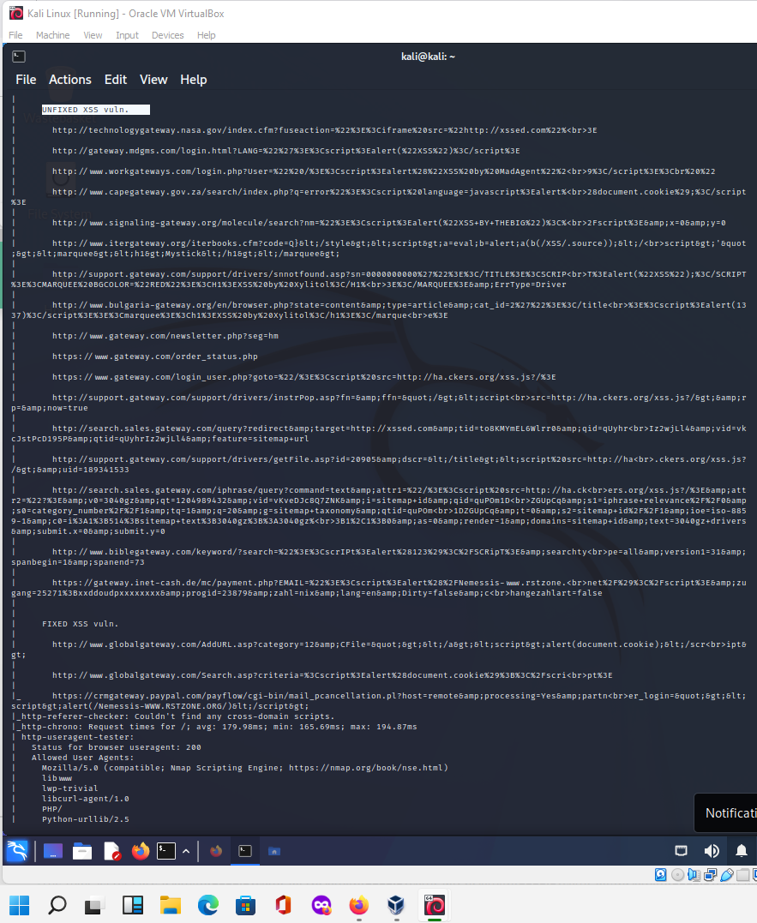

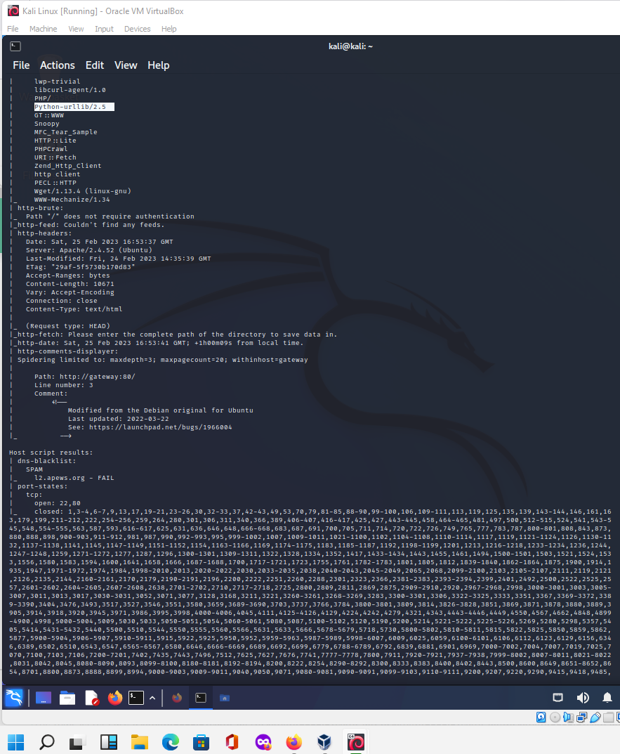

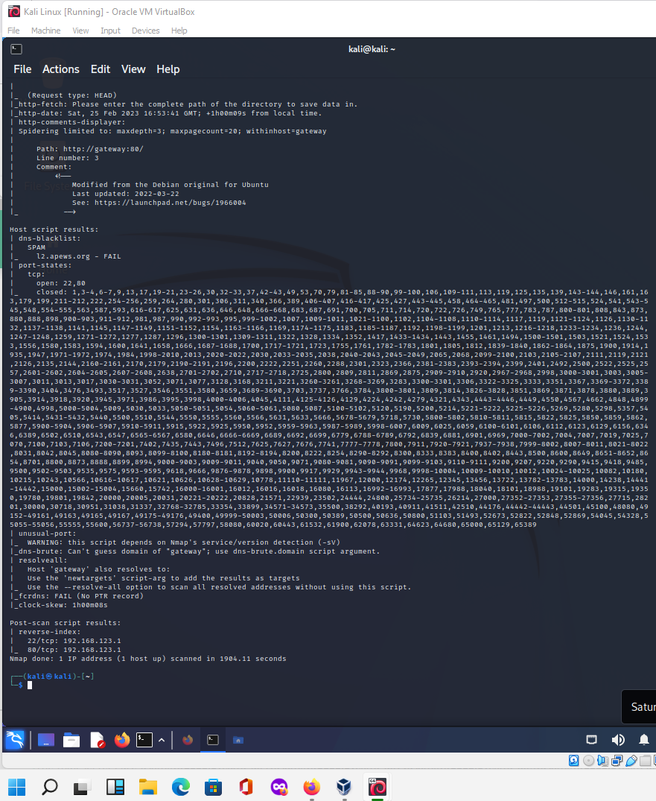

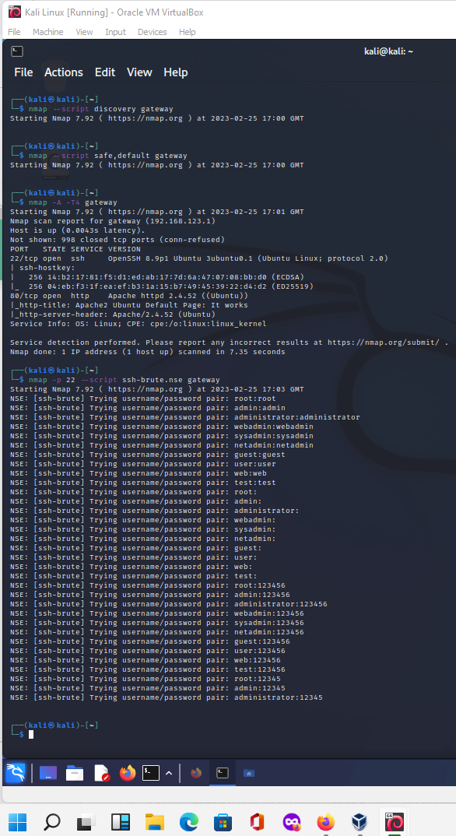

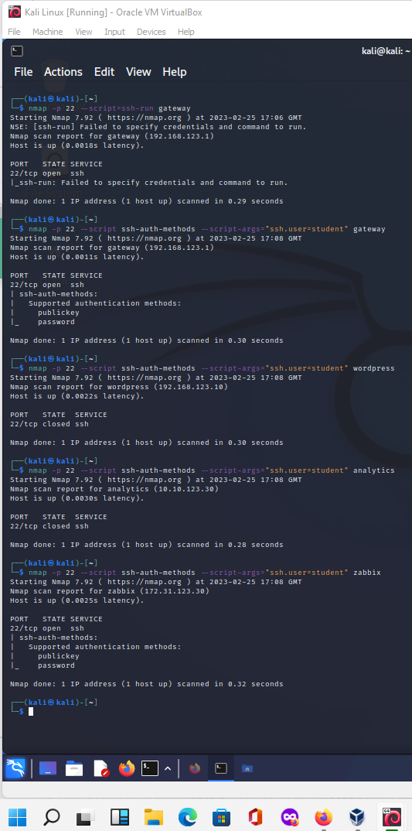

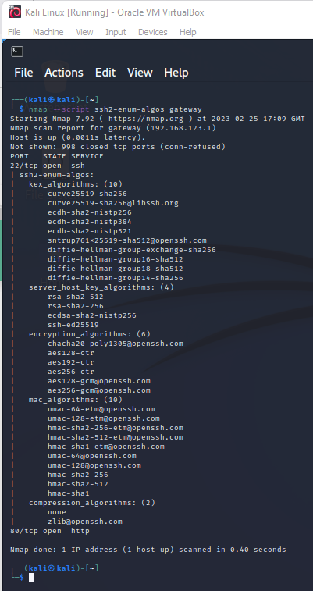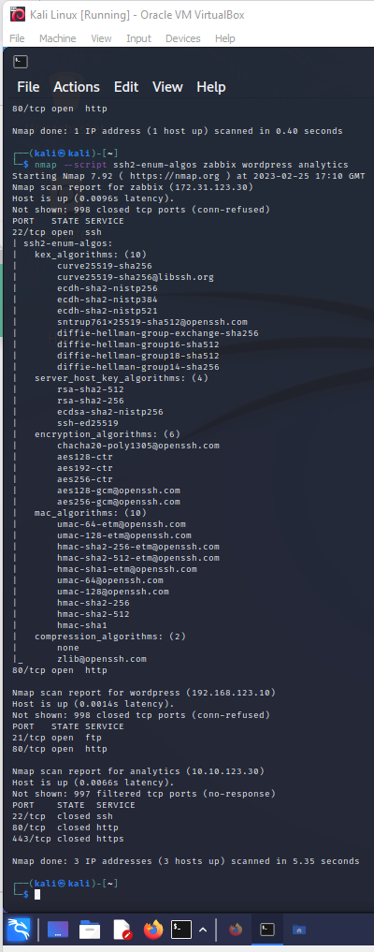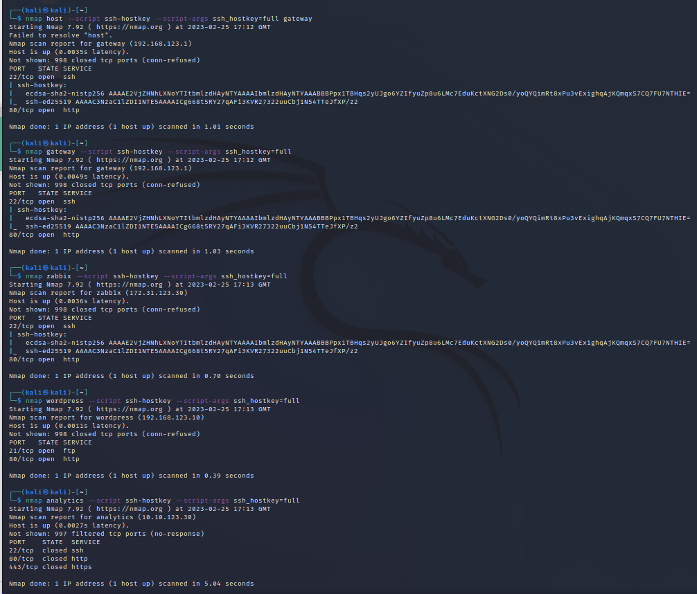

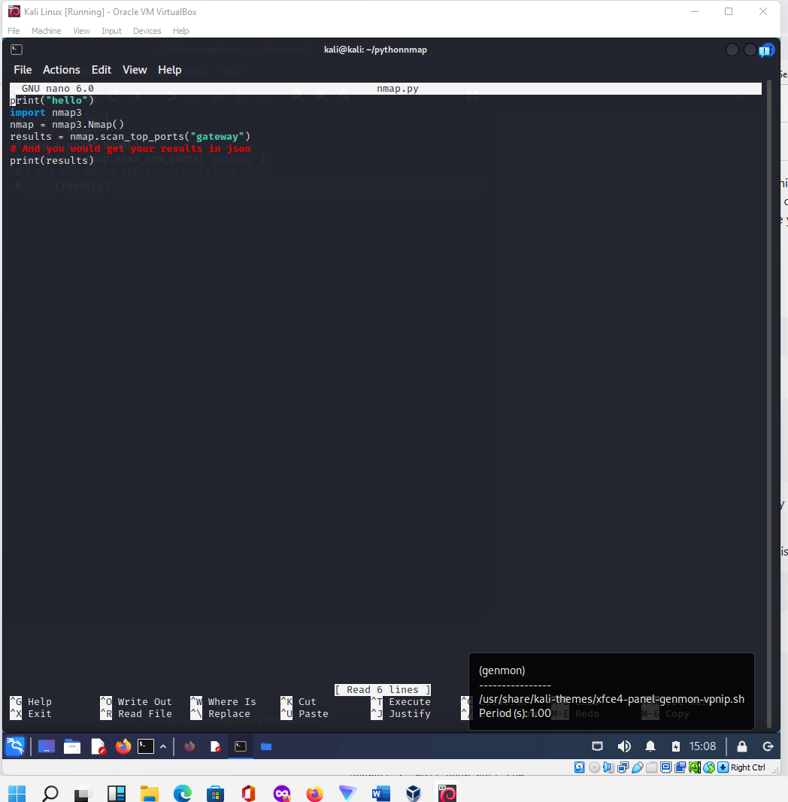

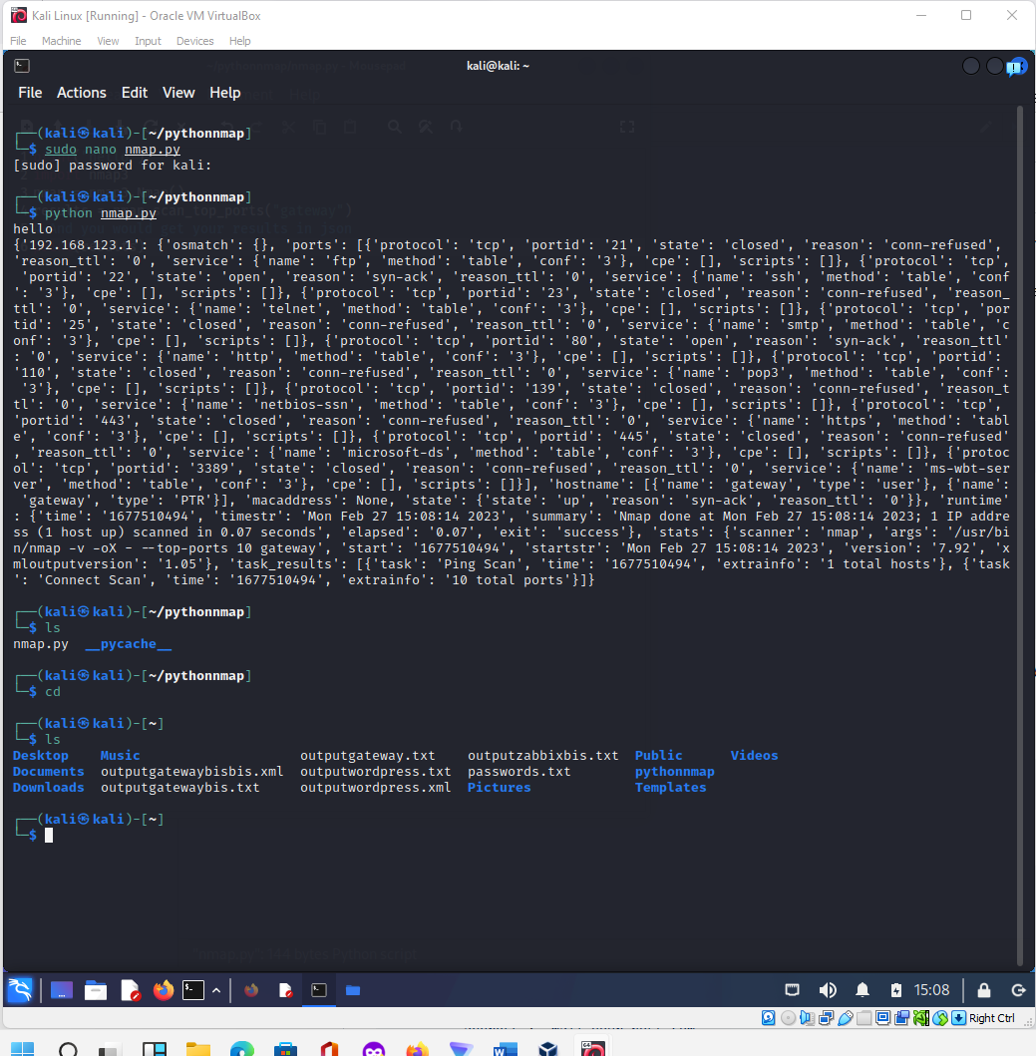

Please complete the following table and upload this document to Moodle.

|  |  |
| --- | --- |
| **Declaration** | I certify that the work for this portfolio lab is my own work. |
| **Brief WOW Factor Description** (if completed) | Req. A and Req. B has wow factor included in screenshots. Participation in Moodle discussions. Python on Kali with nmap. |
| **Student Name:** | Tony |
| **Student ID:** | YIT19488399 |

**##################END#################**